Reporting Exception Time - Full-Time Employees

Click on the “Report Time” tile
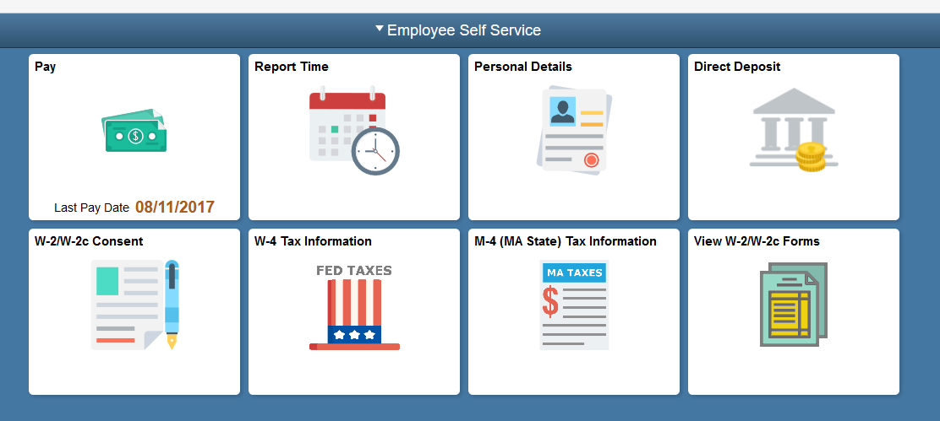
- Use the Timesheet page to report exception hours and time reporting codes for the current time period.
  - Before you enter time, you can check the balances for Sick, Personal, Vacation, Comp and other leave plans in which you are enrolled. Click on the Leave/Compensatory tab.
- For example, if on Tuesday, you were out sick (assume 8 hour/day work schedule). Enter “8” into the Tuesday field.
- Click the Time Reporting Code dropdown list.
- Scroll to SIC - Sick Time code.
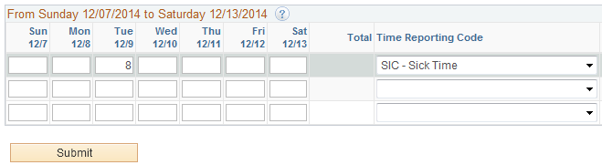

- If you don’t have any other exceptions to report, click the Submit button.
- Click the OK button.

REMINDER: If you used 4 hours sick time, for example, be sure to also record 4 hours REG (regular time) to make the day whole. Total hours must equal your scheduled work day.

